Company name: Sol-Bright Tech

Home page
会有一个视频可能是从YOUTUBE 那边链接过来的 然后简单配几张图片 其他的我不熟悉添加什么好 你觉得有什么要的也可以加进来 毕竟我不是专业的。首页最好放大图 大图好点 在我没拿到新图片前 也可以用一些别的来代替。

然后就是 在上面一排有这些链接
INTRODUCTION, PROBLEM&CHALLENGE, OUR TECHNOLOGY, TEST&RESULT, PRODUCT A& SERVICE, GALLERY, NEWS &EVENT , FAQ， CONTACT US。

Company Introduction:

Sol-Bright Tech is one of the world’s leading professional manufacturers that builds the most practical and intelligent robot to clean photovoltaic modules.
We focus on value-adding and customized services in the solar industry. Our company focuses on R&D and services to
continuously bring the best technological solutions to our valued customers.
In recent years, with the rapid development of the photovoltaic industry, large-scale solar power plants are being built at a rapid
speed around the world. However, with large scales of solar panels, soiling has caused a significant decrease in efficiency in power
generation and has become a prominent issue to operators and owners of large-scale solar power plants. Sol-Bright Technology
grasped the significance of this problem and regarded it as an opportunity for innovation and growth.
After many researches, trial and errors, Sol-Bright Technology successfully developed their first generation of intelligent cleaning
robot in 2013. The advanced technology behind the innovation has obtained patents both domestically and internationally. It is also
highly acknowledged by many industry experts and has been recognized at SNEC expo in 2015.
Sol-Bright Technology provides the turnkey solution to utility scale solar power plants. Our team provides customized
manufacturing, assembling and provides onsite installation with professional after-sales maintenance services to our customers.
We abide by the values of integrity, technology oriented, and continuous innovation to provide the best solution to our clients. We
have committed ourselves to the mission of developing green energy resources to build a greener world for tomorrow.

POBLEM&CHALLENGE
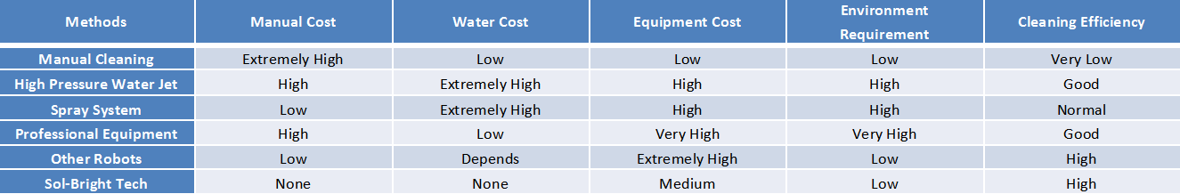
Want to clean all your panels every month by manual? That is really expensive.
Want to use Water Jet or spray system? Water may be your biggest problem.
Professional equips cannot maintain balance because your rough road, and it is not cheap at all.
Want to buy some robots? They are too expensive? Try Sol-Bright Tech, the most cost-effective cleaning robot all over the world!

OUR TECHNOLOGY
Our robot use the edge of the PV panel as a track, need not to add new track beside panels. The electrical motor drive the brush and the wheel at the same time, so the robot move horizontally along the PV panels and the brush rolling on the surface of the PV panel, make the PV panel clean during their movement.
EIGHT ADVANTAGE
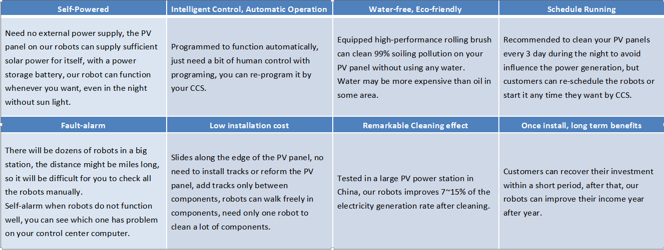
Compare with other company product
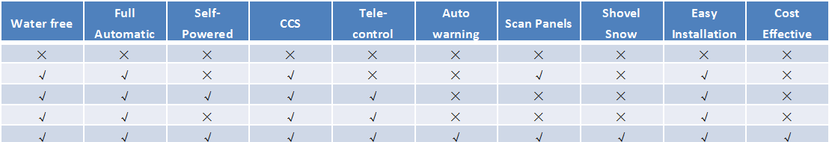

TEST&RESULT
There is a Successful Case:
There is one China PV power station is the first water surface PV power station of GCT Group. Photovoltaic modules are distributed above the water and aquaculture is performed underwater, with 30MW of generating capacity.
And we did the test based on two situations: the 1st test is based on not clean the solar panel for 3 days, and the 2nd test is not clean for 10days. As you can see the difference between the component peak power value.
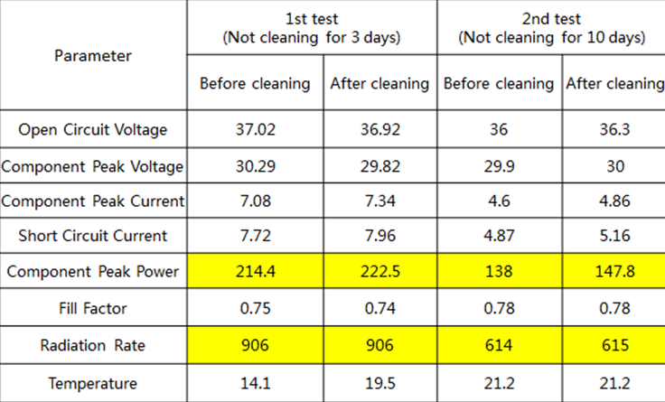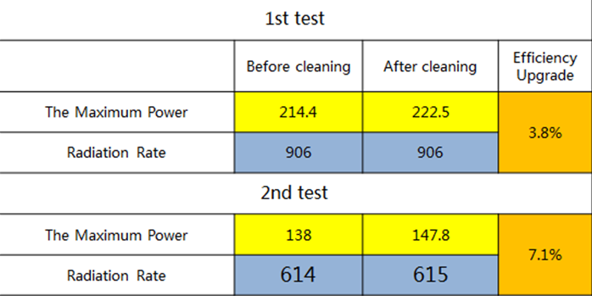
As the result , the efficiency increased aouth 3.8% to 7.1%. It is a huge difference.
And we have done some simple calculation for them.
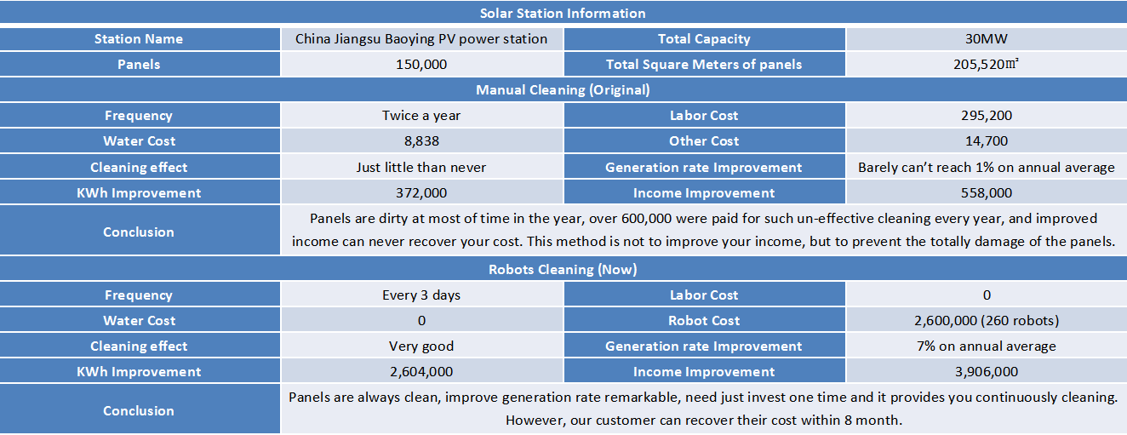
As long as you choose Sol-bright Tech , your company can recover the cost in less than 1year and half.

Product and Service

18 months warranty, lifelong repair;
Free technical consultation
Provide repair/replacement/technical support during warranty period；
Specialized customer service phone number；
Troubleshoot within shortest time.

Gallery
目前只有两张效果图 我先放假E-MAIL 中了。
NeWS AND EVENT
这里可能需要分几个链接 介绍一些近况 比如第一个
SOL-BRIGHT TECH will attend the SNEC meeting which holds in Shanghai this year. 这样的标题 ,然后在链接进去 是一篇文章。

FAQ
Frequently Asked Questions

1.) Does the Sol-Bright Tech Robot detect, or sense, special environmental conditions, that will stop the cleaning operation? For example, can it be programmed to do periodic cleaning during night hours, to avoid shadowing? Or can it work when snowing?
The Sol-Bright Tech has a fully up-gradable, on-board, electronic communication and sensing system (CSS). After improved the built-in battery, robot can operate in the temperature of up to 70℃ and down to -40℃. As part of this improvement package, temperature sensor system will ensure that robot works under allowed temperature to avoid breakdown, in addition, the temperature sensor will detect abnormal temperatures in the panel, while it is being cleaned. This will allow accurate pinpointing of faulty panels for easy change-over.

2.) What are the dimensions (especially the cleaning area) and weight of Sol-Bright Tech Robot?
Sol-Bright Robot is capable of cleaning panel arrays of up to 5.35 m width and a length of up to 800m. Various scale can be customized for the special measurement of panel arrays. For most mono-crystalline panel designs, this means a single unit will be dedicated to a 75 KW array string. The system weighs less than 50 kg, and the modified material will further reduce this weight.

3.) How is it installed and how does it move through the module surface and array of modules? Can it be physically moved from one array of modules to others, or do we need a cleaning system per array?
The robot is installed onto an array with the use of a row of rubber wheel that fixes the whole robot to the top of solar module-frame, and other rows of rubber wheels perpendicular to the panel surface will bear the weight averagely to keep the whole package in balance. These wheels are all set up to move along the module-frame so that robot does not have any rest weight on the panel surfaces themselves. Robot only can moved one array of modules to others which are parallel with former via bridge connection. This system is designed to be cost-effective with a single robot dedicated to each row. There are a number of reasons for this, the 1st being that all operational labor requirements are avoided. This is an often overlooked necessity of desert cleaning systems, when temperatures can remain at more than 40° during the night, and labor supply is scarce and expensive to maintain and supervise. Similar situation occurs in the developed countries, labors are not allowed to work under high temperature. The second is that by dedicating one system per row, the dangers of manually moving the system from one road to another, or running out of operational capacity during badly weather periods is completely avoided.

4.) How does it physically interact with the panel surface; could it erode or scratch a coated glass surface?
We have done several thousand passes with the Sol-Bright Tech brush system, and have recorded essentially zero scratching or service degradation in that time on both mono crystalline and poly crystalline panels. The brushes very specially designed to optimize a large number of variables such as feed and speed rate, brush bristle density and pattern, bristle material, length and diameter. This in turn is installed as a part of drive system, which allows the brushes to interact with the panel surface inverted to the direction of motion, and causes the dust to flick rather than grind as it is removed, also make the dust moved forward so that avoiding the dust soiling the cleared panel again. This allows the robot to remove large or small quantities of dust without water. 200 robots have been installed in Boaying PV station, no erode and scratch reported.

5.) Is manpower needed for the system operation and/or control?
No manpower is required for the operation of Sol-Bright Tech Robot, beyond a single operator in a remote location who can oversee the site from a distance and observe the operational characteristics of each device in real-time through remote sensor viewing and network communications.

6.) Is there a real time monitoring system giving information about the cleaning progress and system itself (alarms, failures)? How does it communicate with this control unit?
The electronic system on board is currently being upgraded to allow wireless communication, so key operating characteristics can be observed at all times remotely. If any robot malfunctions, the system will show you which one is breakdown.

7.) What are the components of the system? What are the spare parts needed?
The robot is constructed from simply manufactured fiberglass components, requiring a minimum of machining and using sections that are standard sizes. Fittings are stainless steel, and the rollers are similar to those found on heavy duty lifting equipment. This makes the superstructure and translation structure extremely rugged and durable, with no exposed perishable parts. Even the brushes, are tough enough to be used at least two years, and it’s easy and cost-effective to change for.

8.) What are the consumables (cloths, brushes etc.) and characteristics of the cleaning tools? How often shall they be replaced? Are they industrial parts that can be easily found/purchased when needed?
The fiberglass shell is coated by coated banner, which is a kind of really tough cloth, excellent capability of anti-oxidation, acid and alkali resistance, anti-severe cold, which is designed a ten years of lifetime as long as the robot serve the panel module. The other consumable which cared much are brushes. As we mentioned above, the brushes are of a special but commonly available material to make sure they are soft enough the clear the panel surface and tough enough to serve at least two years. All these parts can be rapidly got from the Sol-Bright Tech office in Europe.

9.) What are the operating time of the battery and the charging time? Can batteries be exchanged or does the device need to go to a special recharging area and stop work?
One advantage of this robot is that it has self-powered system. The solar ceil set up at the top of shell can uninterruptedly supply power to store in on-board battery when well-shined so that robot can work both in day and night. The system can detect current buttery quantity to calculate how further it can run, the robot will come back to the bracket installed at both end of panel module before the buttery running out and recharged there. When charged, the robot can run for double the operating time required to traverse an array in both directions.

10.) What is the real cleaning speed (m2/min)?
On a 3 m width array, travelling at 0.25 m/s, the device will clean 90m2 per minute, and finish its there-and back pass of the entire row in under 30 min.

11.) Where is the device stored during the non-operating times?
A support bracket is installed at the end of the row to accommodate the robot when it is not being used. This protected from the robot shadowing a substantial amount of the light during the day.

12.) Is water, compressed air or electricity additionally needed to run the cleaning system?
No. Each Sol-Bright Tech robot unit runs completely independently and without any external cables, on-board water supplies or air reservoirs, or any other such highly unreliable operational requirements commonly seen on cleaning systems that have been developed.

13.) What specifications are needed to install the Sol-Bright Tech robot on different array designs?
The integration of Sol-Bright Tech system with an array design depends on the measurement of the array structure. The system can vary simply be integrated during the design phase with a simple custom bracket that clasps the upper frame of solar module array which at least has load-bearing capacity of 100kgs. The more solar module combined in width, more wheels will be fitted in row in the robot to averagely bear the weight by each row. By the same way, the motor power is changed to satisfy the energy that robot needs to run the end. For the simply structure, installation can be undertaken using very cheap and low skilled Labor.

14.) What are the smallest and largest ranges of measurements it works with?
The Sol-Bright Tech system is economical for any system ranging from a single 75 kW row, up until any size array, given that one Sol-Bright Tech robot is dedicated per row and completely scaleable. Longer rows of up to 400 kW can also be accommodated. The advantages of having a fully automated cleaning solution for 2 to 500 MW Systems, fully scalable and completely modular, is obvious.

15.) What is the most problematic kind of residue accumulation to clean with this device? The easiest?
The most difficult residue to clean for any manual or automatic cleaning method is bird droppings. We suggest that commend the robots by manual remote control to clean frequently after raining as the bird droppings swelled up when soaked, that’s easy to clean up. The other advantage of having daily cleaning cycles is that the dust deposits do not have time to stick fast to the panels over several days. Leaving the cleaning cycle for longer periods means dust has more opportunity to chemically bonds to the surface of the panels, leaving watermarks and difficult to clean residues behind.

16.) What type of adjustments is needed for maintenance of the device and how often should they be done?
The patent pending brush mounting system has an inbuilt self-adjustment process that allows the system to find its optimum gravity-adjusted angle of progress as it cleans. The clamping wheels on the patent pending track and cart assembly have a single screw adjustment that allows for tightening of the system as the wheels wear slightly over several years, keeping the system running snuggly on the rail. No other adjustments are necessary during the operation of the system. Once the height has been adjusted using a simple screw Jack at the point of installation, the system will remain in operational adjustment for the remainder of its lifetime.

17.) What is the estimated longevity for the device?
The superstructure of the device is made from glass fiber reinforced plastics-high performance tarpaulin, which is more rugged and lighter than stainless steel, has at least 10 years of lifetime. The very few, very simple, consumable parts, such as bearings and motors are to be changed on the maintenance cycle mentioned above. The rugged simplicity of the Sol-Bright Tech is one of its most powerful features. With only six main parts, very little is susceptible to short lifespans. .

18.) Is a dry module surface always needed, or the device can operate properly on wet modules? Would there be any advantages?
Well, it depends. A dry surface is needed to clean dust. The bird droppings and moss should be cleared when the rain passed.

19.) Does the brush need cleaning?
No. The brush is made of a special material to avoid dust adhering to it, so there is no need to take any labor force on cleaning.

Contact us :
先空白吧

